A
PROJECT REPORT
ON
“ FINDASH –
PERSONAL FINANCE AND STOCK ANALYSIS PLATFORM ”
SUBMITTED TO
PATEL GROUP OF INSTITUTIONS

(MCA COLLEGE, AICTE APPROVED AND AFFILIATED TO GTU),
MEHSANA
GUJARAT TECHNOLOGICAL UNIVERSITY

FOR
THE VIIITH SEMESTER OF IMCA(YEAR 2025-26)
PREPARED BY:
KUNJ MANISHKUMAR RAMI [225480686012]
UNDER THE GUIDANCE OF
[INTERNAL GUIDE, PGI]
Prof. Ahesan Shekh
CERTIFICATE
 Date: 01/06/2026

This is to certify that Mr. Kunj Rami of IMCA Sem 8 & session VIII (2025-2026) Enrollment No. 225480686012 is a bonafide student of this Department. They have completed their project work on the topic Findash – Personal Finance and Stock Analysis Platform in the College Patel Group of Institutions, Motidau, Mehsana of the Session 2025-26. He have successfully submitted the project report.

Internal Examiner
Prof. Ahesan Shekh

Mentor-I
Prof. Ahesan Shekh
__________________________

Head OF Department [MCA] External Examiner
Prof. Adnan Ahmad
______________________ ____________________

ACKNOWLEDGEMENT

I take this opportunity to express our profound gratitude and deep regards to our guide “Prof. Ahesan Shekh” for her exemplary guidance, monitoring and constant encouragement throughout the course of this thesis. The blessing, help and guidance given by her time to time shall carry us a long way in the journey of life on which.
I am about to embark. I also take this opportunity to express a deep sense of gratitude to “Prof. Ahesan Shekh” for their cordial support, valuable information and guidance, which helped me in completing this task through various stages.

Kunj ManishKumar Rami [225480686012]

INDEX
1. INTRODUCTION 5
1.1 Existing System 5
1.2 Need for the New System 6
1.3 Objective of the New System 6
1.4 Problem Definition 7
1.5 Core Components 7
1.6 Project Profile 8
1.7 Assumptions and Constraints 8
1.8 Advantages and Limitations of the Proposed System 9
2. REQUIREMENT DETERMINATION & ANALYSIS 10
2.1 Requirement Determination (SRS) 10
2.2 Targeted Users 12
3.1 Use Case Diagram 14
3.2. Class Diagram 15
3.3. Interaction Diagram 16
3.4. Activity Diagram 17
3.5 Data Dictionary 18
4. Development 20
4.1 Screenshots 20
5. Agile Documentation 26
5.1 Agile Project Charter 26
5.2 Agile Roadmap / Schedule 27
5.3 Agile Project Plan 27
5.4 Agile User Stories 28
5.5 Agile Release Plan 29
5.6 Agile Sprint Backlog 30
5.7 Agile Test Plan 31
5.8 Earned Value and Burn Charts 32
6. Proposed Enhancements 33
7. Conclusion 34
8. Bibliography 35

1. INTRODUCTION
Findash is a web-based financial dashboard and portfolio management system that allows users to track stock market performance, manage investment portfolios, maintain personalized watchlists, and analyze stock data through an interactive and user-friendly interface.
The application combines real-time market information, portfolio tracking, and stock analytics into a single platform. Findash is developed using React, FastAPI, MongoDB, and Yahoo Finance APIs to provide investors with a centralized financial management solution.

1.1 Existing System
Currently, investors use platforms such as Groww, Zerodha Kite, Yahoo Finance, and Moneycontrol to monitor stocks and manage investments.
These platforms:
• Focus on specific functionalities rather than providing a fully customizable dashboard.
• Often require users to switch between multiple applications for research and portfolio tracking.
• Provide limited personalization options.
• May be complex for beginner investors.
• Do not always offer a unified view of portfolio performance and market insights.

1.2 Need for the New System
❖ Centralized Dashboard
To provide a single platform for stock analysis, portfolio management, and watchlist monitoring.
❖ Portfolio Tracking
Enable users to track investments and evaluate portfolio performance efficiently.
❖ Real-Time Market Information
Provide live market insights, stock prices, and financial indicators.
❖ Personalized Watchlists
Allow users to create and manage customized stock watchlists.
❖ User-Friendly Interface
Provide a modern and responsive interface for investors of all experience levels.

1.3 Objective of the New System
❖ Investment Management
Enable users to manage and monitor their stock portfolios.
❖ Market Analysis
Provide detailed stock information and performance charts.
❖ Financial Dashboard
Offer a centralized dashboard containing market overview and portfolio insights.
❖ Personalized Experience
Allow users to create customized watchlists and track favorite stocks.
❖ Secure Platform
Implement secure authentication and user account management.

1.4 Problem Definition
There is no single lightweight web application that combines portfolio management, watchlist tracking, stock search, and market analysis in a unified dashboard.
Investors require:
• A centralized platform to manage investments.
• Easy access to stock information.
• Real-time portfolio tracking.
• Personalized watchlists.
• Secure and reliable account management.

1.5 Core Components
- Frontend (React Application)
o Developed using React.js, Vite, Tailwind CSS.
o Handles user interactions and dashboard visualization.
- Backend (FastAPI)
o Provides REST APIs for authentication, portfolio management, watchlists, and stock data.
o Handles business logic and communication with the database.
- Database (MongoDB)
o Stores user accounts, portfolios, watchlists, and stock metadata.
- Authentication System
o JWT-based authentication and authorization.
- Portfolio Management Module
o Add, update, delete, and track investment holdings.
- Watchlist Management Module
o Add and monitor favorite stocks.

- Stock Analytics Module
o Search stocks and display charts, indicators, and market data.

1.6 Project Profile
Project Title | Findash – Financial Dashboard and Portfolio Management System
Frontend Technology | React.js, Vite, Tailwind CSS
Backend Technology | FastAPI (Python)
Database | MongoDB
State Management | Zustand
Charts & Analytics | Recharts
API Provider | Yahoo Finance API
IDE Used | Visual Studio Code
Documentation Tools | Microsoft Word, Draw.io, PowerPoint
Developed For | Investors, Traders, Finance Enthusiasts, Students
Developed At | Patel Group of Institutions
Developed By | Kunj Manishkumar Rami (225480686012)

1.7 Assumptions and Constraints
Assumptions | Constraints
• Users have internet connectivity. | • System depends on third-party market data providers.
• Stock market data is available through external APIs. | • API rate limits may affect data retrieval.
• Users possess basic knowledge of stock market concepts. | • Real-time data accuracy depends on external services.
• MongoDB services remain available during application usage. | • Internet connection is mandatory.

Advantages | Limitations
• Centralized financial dashboard. | • Dependent on third-party financial APIs.
• User-friendly interface. | • Internet connectivity required.
• Portfolio tracking and management. | • No direct trading functionality.
• Personalized watchlists. | • Market data availability depends on API providers.
• Secure authentication system.
• Interactive market visualizations.
• Scalable architecture using FastAPI and MongoDB.

1.8 Advantages and Limitations of the Proposed System

2. REQUIREMENT DETERMINATION & ANALYSIS

2.1 Requirement Determination (SRS)
Software Requirement Specification (SRS)
Project Title: Findash – Financial Dashboard and Portfolio Management System
Objective
To develop a web-based financial dashboard that enables users to monitor stock market performance, manage investment portfolios, maintain personalized watchlists, and analyze stock data through an interactive and secure platform.
Functional Requirements
User Module
• Register new user accounts
• Secure login and authentication
• Manage user profile information
• Logout functionality
Portfolio Module
• Add stock holdings
• Update existing holdings
• Delete holdings
• Calculate portfolio performance
• View investment summary
Watchlist Module
• Add stocks to watchlist
• Remove stocks from watchlist
• View personalized watchlist
• Track favorite stocks

Stock Management Module
• Search stocks by symbol or company name
• View stock details
• View market statistics
• Access stock performance charts
Dashboard Module
• Display market overview
• Show top gainers and losers
• Display portfolio summary
• Provide quick access to watchlists
System Features
• Responsive web interface
• Secure authentication using JWT
• Real-time stock information
• Portfolio tracking and management
• Watchlist management
• Interactive charts and analytics
Non-Functional Requirements
Requirement | Description
Performance | Fast loading dashboard and efficient API response times
Security | Secure authentication and encrypted password storage
Scalability | System should support future expansion and additional features
Reliability | Stable performance with proper error handling
Usability | User-friendly and intuitive interface
Maintainability | Modular architecture for easy updates and maintenance

Software / Tools Used
• Frontend: React.js, Vite, Tailwind CSS
• Backend: FastAPI (Python)
• Database: MongoDB
• State Management: Zustand
• Charts: Recharts
• API Provider: Yahoo Finance API
• IDE: Visual Studio Code
• API Testing: Postman
• Version Control: Git & GitHub

2.2 Targeted Users
User Type | Description | Access Level
Visitors | Can access public information and application overview | Limited Access
Registered Users | Manage portfolio, watchlist, and stock tracking | User Features
Investors | Monitor investments and analyze portfolio performance | Extended User Features
Traders | Track market movements and maintain watchlists | Advanced User Features
Finance Students | Learn stock market concepts and portfolio management | Educational Usage

System Design (Architecture Overview)
Presentation Layer
React.js frontend application responsible for user interaction, dashboard visualization, and responsive user interface.
Application Layer
FastAPI backend handling authentication, portfolio operations, watchlist management, stock search, and business logic.
Data Layer
MongoDB database used for storing user accounts, portfolios, watchlists, and stock information.
External Service Layer
Yahoo Finance API integration used to retrieve stock market data, company information, and historical price data.

3. System Design

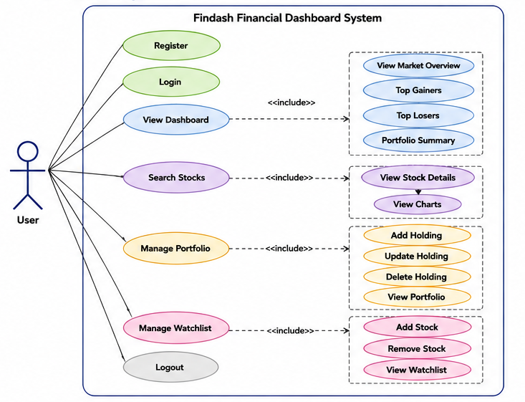
3.1 Use Case Diagram

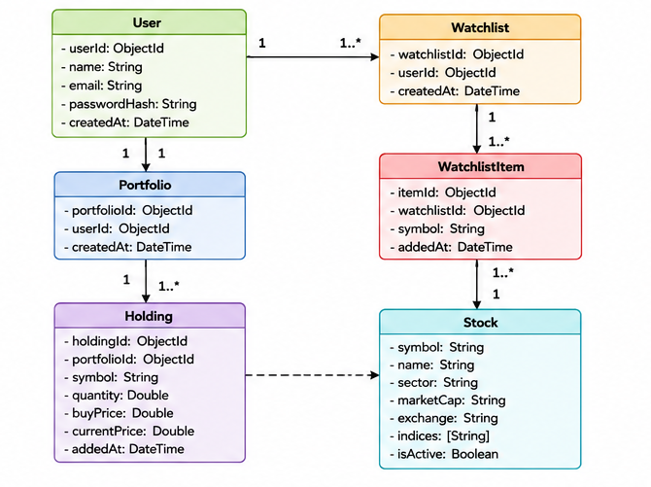
3.2. Class Diagram

3.3. Interaction Diagram
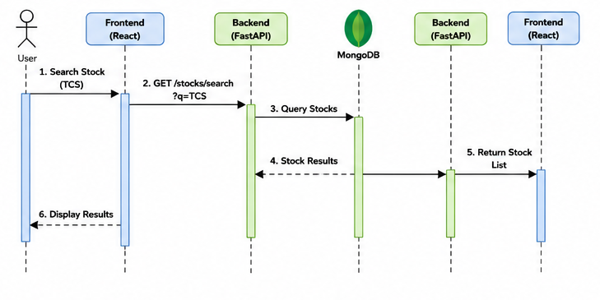

3.4. Activity Diagram
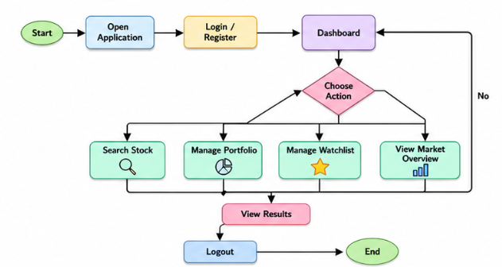

3.5 Data Dictionary

Users Collection
Field Name | Data Type | Description
_id | ObjectId | Unique User ID
name | String | User Name
email | String | User Email
password_hash | String | Encrypted Password
created_at | DateTime | Registration Date

Portfolio Collection
Field Name | Data Type | Description
_id | ObjectId | Portfolio Record ID
user_id | ObjectId | User Reference
symbol | String | Stock Symbol
quantity | Integer | Number of Shares
buy_price | Double | Purchase Price
created_at | DateTime | Holding Creation Date

Watchlist Collection
Field Name | Data Type | Description
_id | ObjectId | Watchlist ID
user_id | ObjectId | User Reference
symbol | String | Stock Symbol
created_at | DateTime | Added Date

Stocks Collection
Field Name | Data Type | Description
symbol | String | Stock Symbol
name | String | Company Name
exchange | String | NSE/BSE
sector | String | Business Sector
market_cap_category | String | Large/Mid/Small Cap
indices | Array | NIFTY 50, NIFTY 500 etc.
is_active | Boolean | Active Status

4. Development

4.1 Screenshots
Register Page
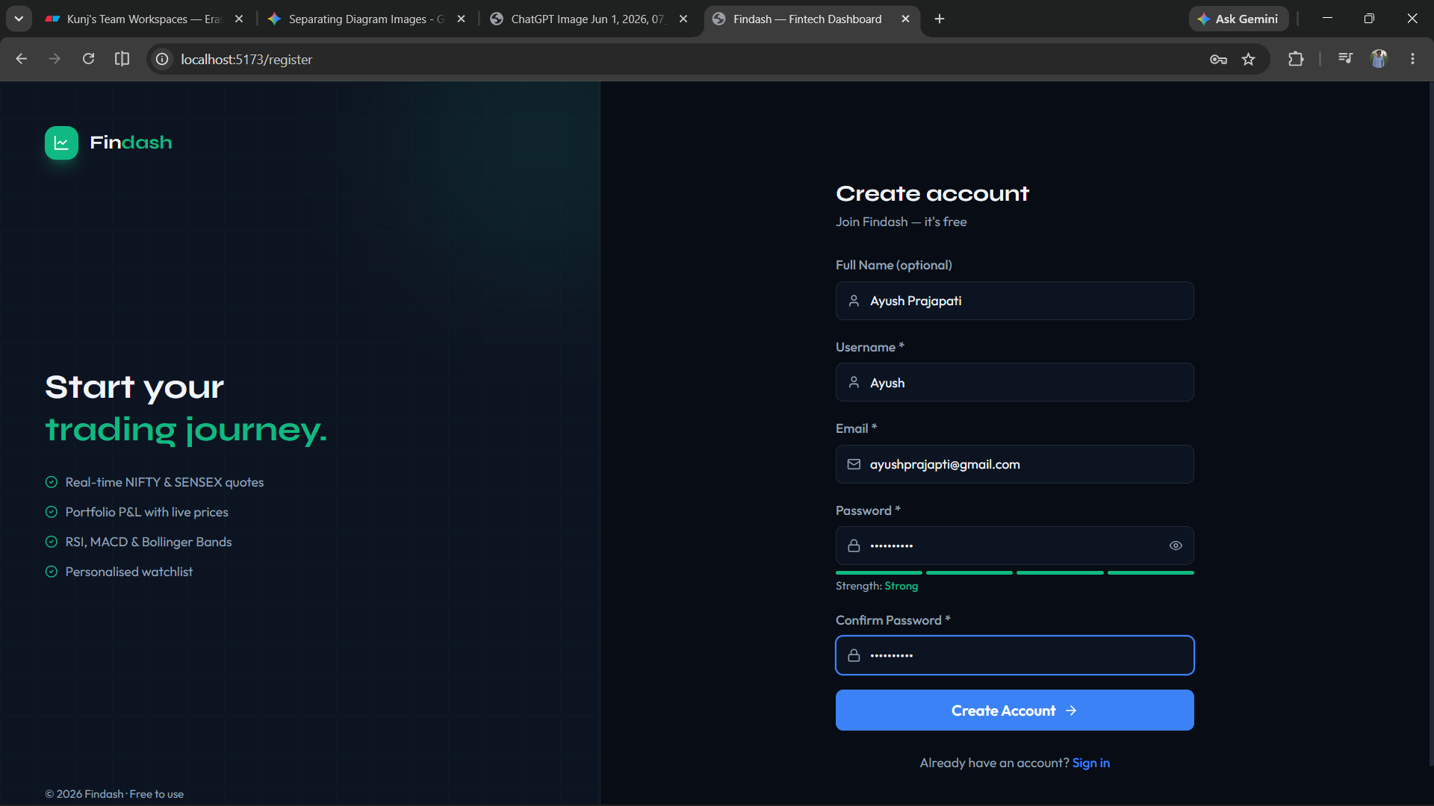
Login Page
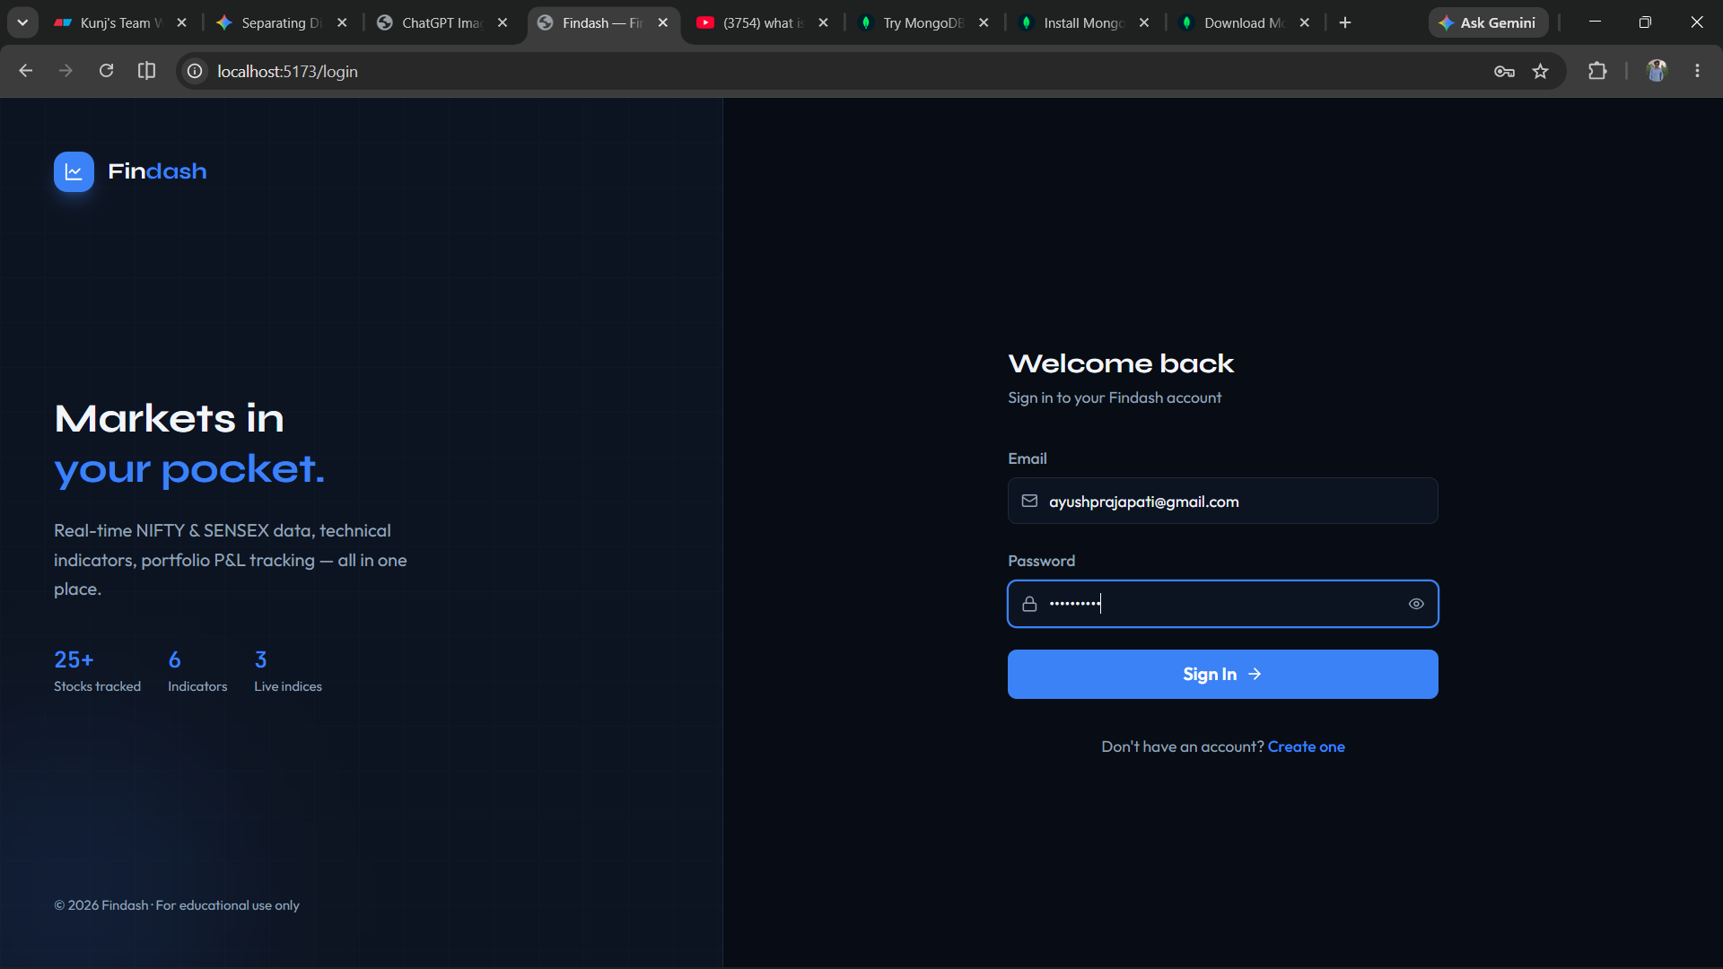

Dashboard
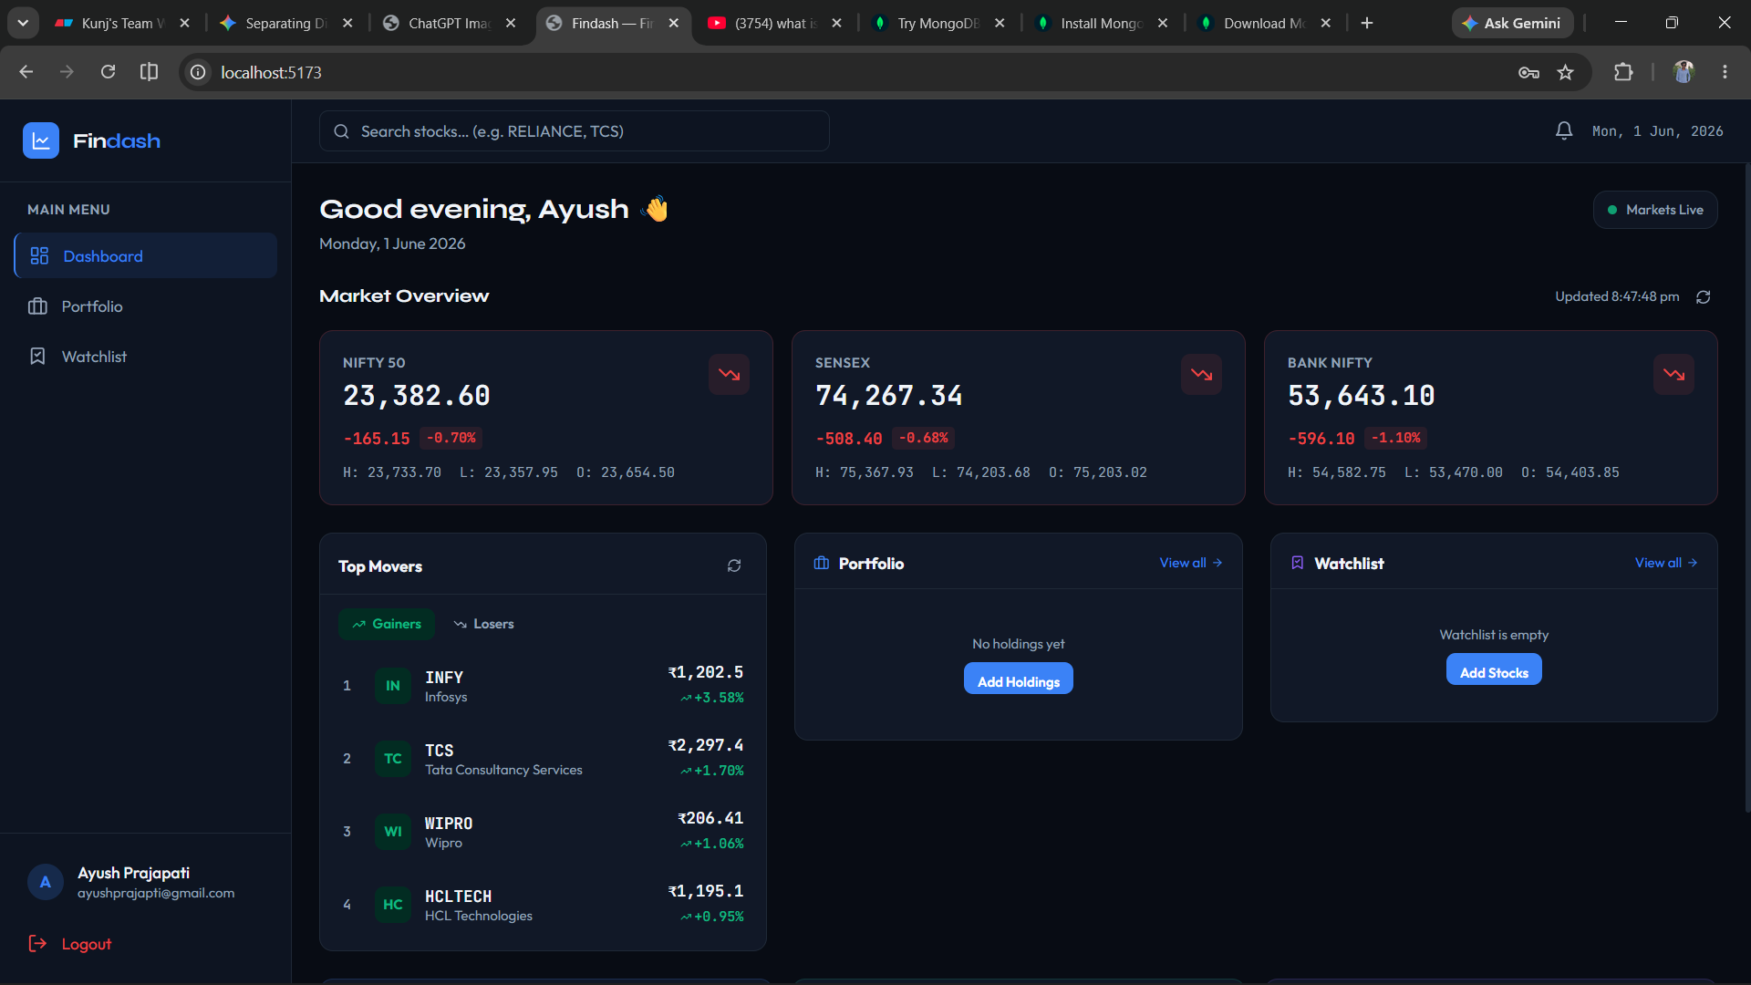
TCS Stock Analysis
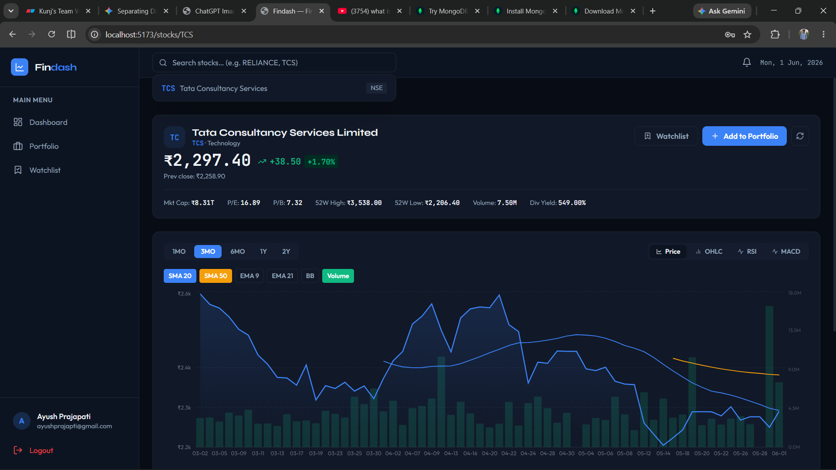

TCS Stock Analysis [OHLCV Chart]
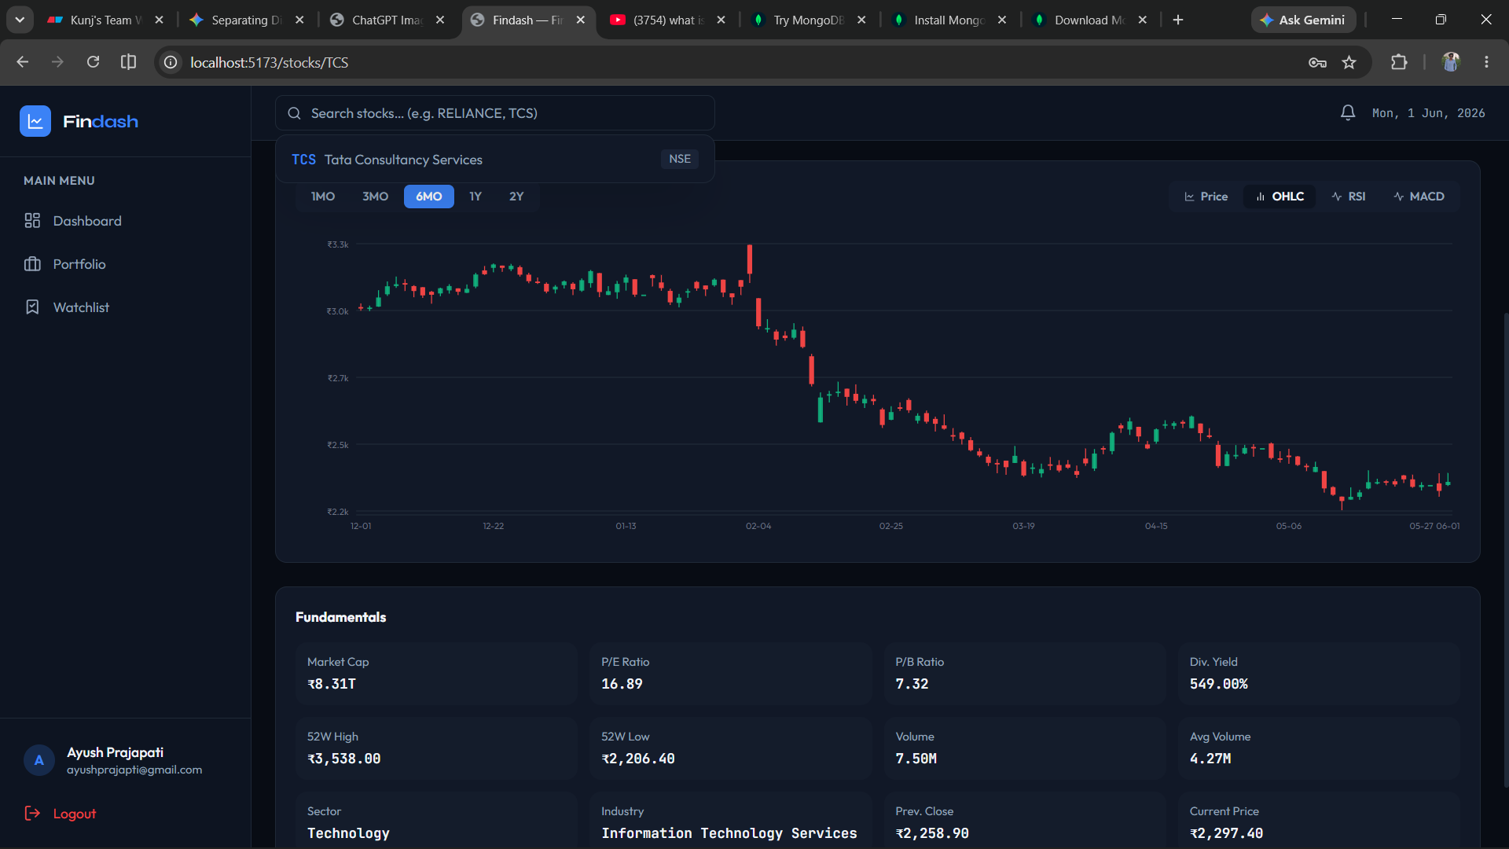
TCS Stock Analysis [RSI Chart]
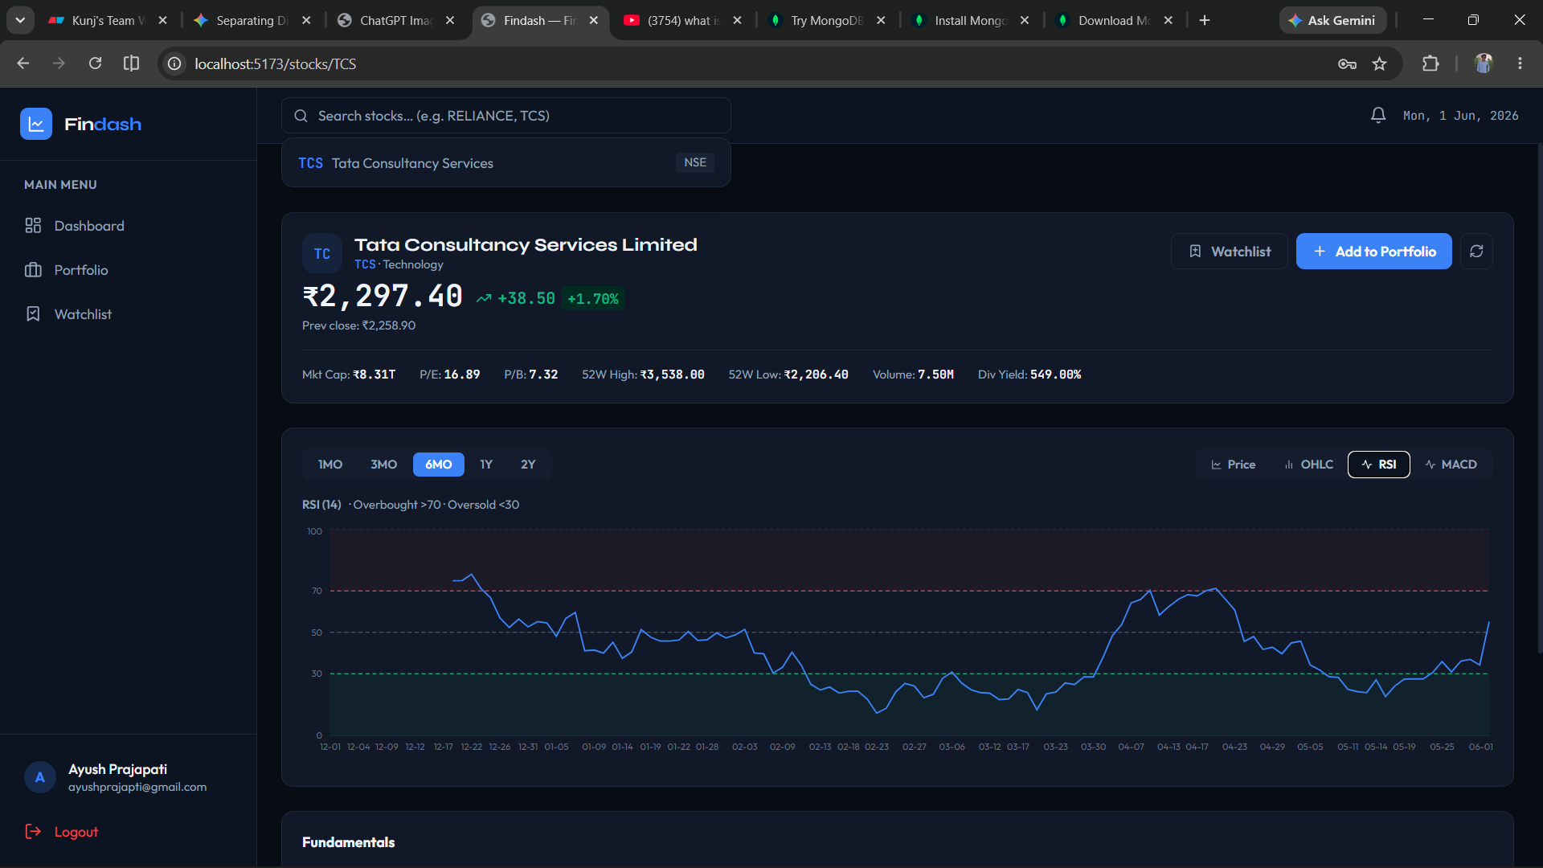

TCS Stock Analysis [MACD Chart]
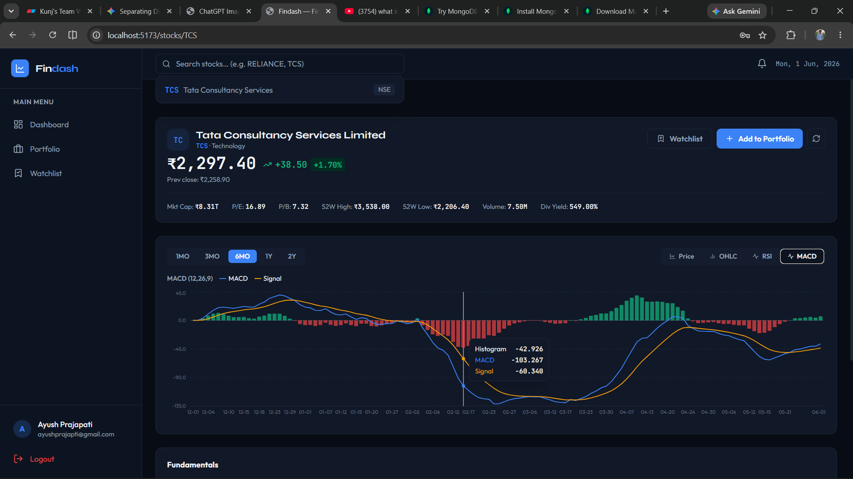
Portfolio Page [No Stocks]
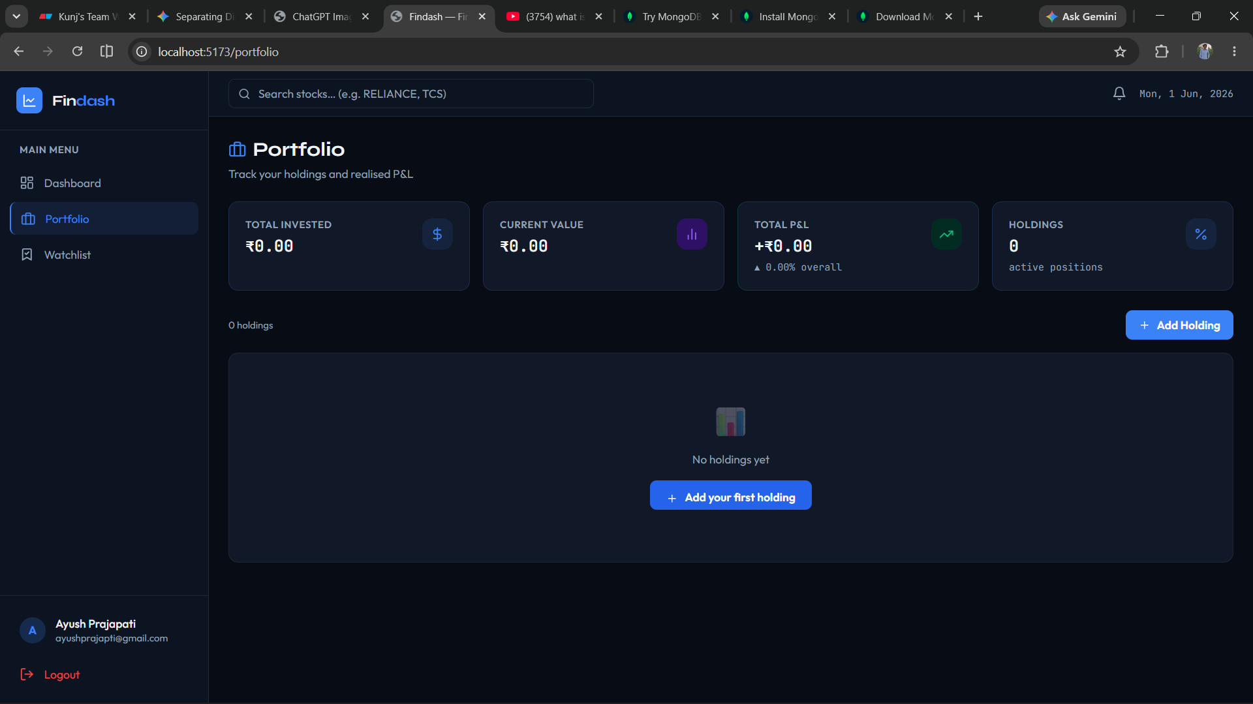

Potfolio Page [TCS stock Added]
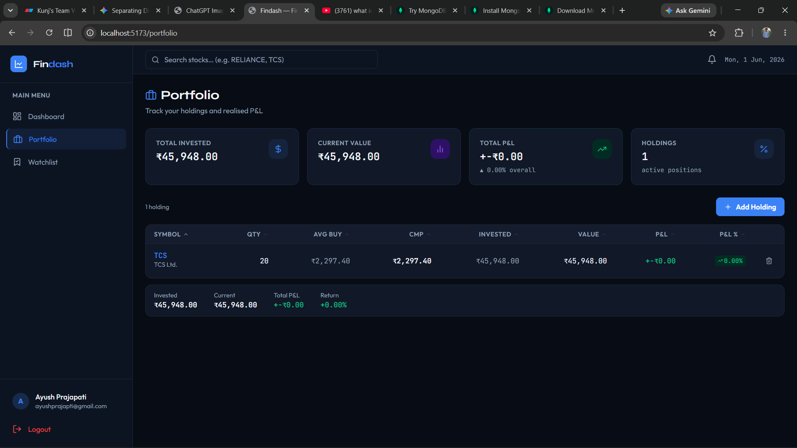
WatchList Page
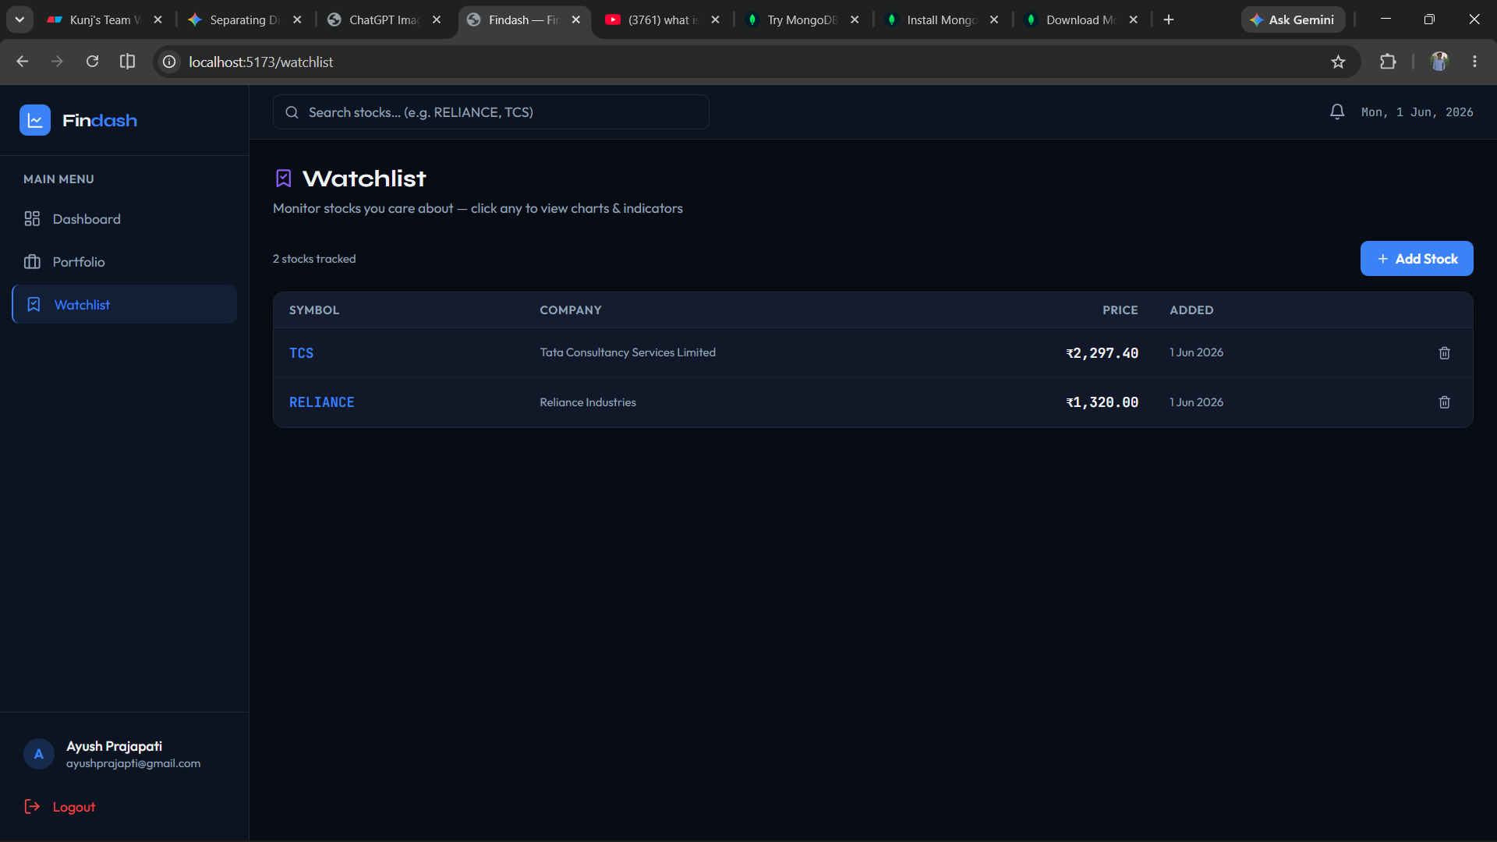

Final Dashboard
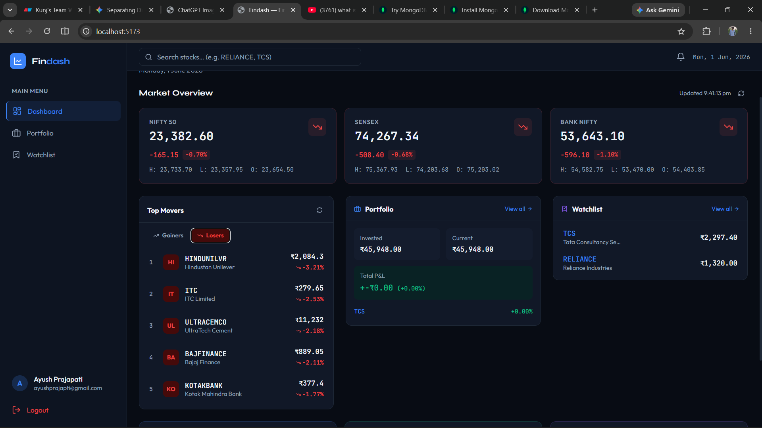

5. Agile Documentation

5.1 Agile Project Charter
Project Title
Findash – Personal Finance and Stock Analysis Platform
Project Vision
To develop a modern financial management platform that enables users to track stock investments, manage portfolios, create watchlists, and analyze market trends through an intuitive dashboard.
Project Objectives
- Provide real-time stock market information.
- Enable users to manage investment portfolios.
- Support watchlist functionality for stock tracking.
- Offer visual analytics through charts and financial indicators.
- Ensure secure user authentication and data management.
Project Stakeholders
Stakeholder | Role
Project Developer | Design, Development and Testing
End Users | Portfolio Management and Stock Tracking
Faculty Guide | Project Evaluation and Guidance
Success Criteria
- Successful user registration and login.
- Accurate stock market data retrieval.
- Portfolio management functionality working correctly.
- Responsive and user-friendly interface.
- Secure data storage and retrieval.

5.2 Agile Roadmap / Schedule
Phase | Duration | Activities
Sprint 1 | Week 1-2 | Requirement Analysis and Planning
Sprint 2 | Week 3-4 | Database Design and Backend Setup
Sprint 3 | Week 5-6 | User Authentication Module
Sprint 4 | Week 7-8 | Stock Search and Market Data Integration
Sprint 5 | Week 9-10 | Portfolio and Watchlist Development
Sprint 6 | Week 11-12 | Dashboard and Data Visualization
Sprint 7 | Week 13 | Testing and Bug Fixing
Sprint 8 | Week 14 | Documentation and Final Deployment

5.3 Agile Project Plan
Sprint 1
- Gather requirements
- Define project scope
- Create database schema
Sprint 2
- Configure backend architecture
- Implement authentication APIs
- Create database models
Sprint 3
- Develop user registration and login
- JWT authentication implementation

Sprint 4
- Integrate stock market APIs
- Develop stock search functionality
Sprint 5
- Portfolio management implementation
- Watchlist feature development
Sprint 6
- Dashboard development
- Chart and analytics integration
Sprint 7
- Unit testing
- Integration testing
- Bug fixing
Sprint 8
- Documentation
- Final review
- Deployment preparation

5.4 Agile User Stories
User Story 1 – User Registration
As a new user, I want to create an account so that I can securely access my financial data.
Acceptance Criteria
- User can register using email and password.
- Validation checks are performed.
- Account is successfully created.

User Story 2 – Add Stock to Portfolio
As an investor, I want to add stocks to my portfolio so that I can monitor my investments.
Acceptance Criteria
- User can enter stock details.
- Portfolio updates automatically.
- Investment value is calculated correctly.

User Story 3 – Create Watchlist
As a user, I want to add stocks to a watchlist so that I can monitor future investment opportunities.
Acceptance Criteria
- User can add stocks.
- Watchlist displays stock information.
- User can remove stocks from watchlist.

5.5 Agile Release Plan
Release | Features
Release 1 | Authentication System
Release 2 | Stock Search Integration
Release 3 | Portfolio Management
Release 4 | Watchlist Module
Release 5 | Dashboard Analytics
Release 6 | Testing and Deployment
Final Release Deliverables
- User Authentication
- Portfolio Management
- Watchlist System
- Stock Analysis Dashboard
- Market Data Visualization

5.6 Agile Sprint Backlog
Sprint Backlog
Task ID | Task Description | Priority | Status
T1 | Setup Project Structure | High | Completed
T2 | Design Database Schema | High | Completed
T3 | Implement Authentication | High | Completed
T4 | Integrate Stock APIs | High | Completed
T5 | Portfolio Module | High | Completed
T6 | Watchlist Module | High | Completed
T7 | Dashboard Development | Medium | Completed
T8 | Testing and Debugging | High | Completed
T9 | Documentation | High | Completed

5.7 Agile Test Plan
Testing Objectives
- Verify system functionality.
- Validate business logic.
- Ensure system stability.
- Detect and resolve defects.
Testing Types
Unit Testing
Individual modules tested independently.
Integration Testing
Interaction between frontend, backend, and database tested.
System Testing
Complete system tested as a whole.
User Acceptance Testing
Application validated against user requirements.
Sample Test Cases
Test Case | Input | Expected Result
User Login | Valid Credentials | Login Successful
Add Portfolio Item | Stock Data | Item Added
Add Watchlist Stock | Stock Symbol | Stock Added
Search Stock | TCS | Stock Details Displayed

5.8 Earned Value and Burn Charts
Earned Value Analysis
Metric | Value
Planned Value (PV) | 100%
Earned Value (EV) | 95%
Actual Cost (AC) | 98%
Schedule Variance | +5%
Cost Variance | -3%

Burn Down Analysis
The sprint burn-down chart demonstrated a steady decrease in pending tasks throughout development. Most critical features were completed within planned sprint durations, indicating effective sprint planning and resource utilization.
The project maintained a consistent development pace and achieved milestone completion within the scheduled timeframe.

6. Proposed Enhancements
The current version of Findash provides portfolio management, stock analysis, watchlist management, and financial tracking capabilities. Future enhancements may include:
- AI-based stock recommendation engine.
- Predictive stock price analysis using Machine Learning.
- News sentiment analysis for investment decisions.
- Multi-asset support including Mutual Funds, ETFs, and Cryptocurrencies.
- Real-time push notifications for stock alerts.
- Budget planning and expense management modules.
- Advanced portfolio risk assessment tools.
- Mobile application development for Android and iOS platforms.
- Integration with brokerage platforms for direct trading support.
- Personalized financial advisory features.
These enhancements will improve user engagement and provide a more comprehensive financial management ecosystem.

7. Conclusion
Findash successfully achieves its objective of providing users with a centralized platform for financial tracking, stock analysis, portfolio management, and watchlist monitoring. The system integrates real-time market data with modern visualization techniques to help users make informed investment decisions.
The project demonstrates the practical application of modern web development technologies, database management, API integration, and Agile software development methodologies. Through its intuitive interface and efficient architecture, Findash enhances the user experience while maintaining scalability and reliability.
The successful completion of this project highlights the importance of technology-driven financial solutions and provides a strong foundation for future enhancements involving Artificial Intelligence and advanced analytics.

8. Bibliography
- React Documentation. Available at: https://react.dev/
- FastAPI Documentation. Available at: https://fastapi.tiangolo.com/
- MongoDB Documentation. Available at: https://www.mongodb.com/docs/
- Python Documentation. Available at: https://docs.python.org/3/
- Yahoo Finance API Documentation.
- Tailwind CSS Documentation. Available at: https://tailwindcss.com/docs
- Framer Motion Documentation. Available at: https://www.framer.com/motion/
- JWT Authentication Documentation. Available at: https://jwt.io/
- Agile Manifesto. Available at: https://agilemanifesto.org/
- Financial Market Analysis and Investment Management Reference Materials.

